**Blinkit Analysis**

• See all the data imported:

SELECT * FROM blinkit_data;

• **Data Cleaning:**

Cleaning the ‘Item Fat Content’ field ensures data consistency and accuracy in analysis. The presence of multiple variations of the same category (e.g., LF, low fat vs Low Fat & reg vs Regular) can cause issues in reporting, aggregations, and filtering. By standardizing these values, we improve data quality, making it easier to generate insights and maintain uniformity in our datasets.

UPDATE blinkit_data

SET `Item Fat Content` =

CASE

WHEN `Item Fat Content` IN ('LF', 'low fat') THEN 'Low Fat'

WHEN `Item Fat Content` = 'reg' THEN 'Regular'

ELSE `Item Fat Content`

END;

After executing this query check the data has been cleaned or not using below query.

SELECT DISTINCT(`Item Fat Content`) FROM blinkit_data;

**KPI’s**

**1. TOTAL SALES:**

SELECT

CONCAT(CAST(SUM(Sales) / 1000000 AS DECIMAL(10,2)), ' Million') AS Total_Sales_Millions

FROM blinkit_data;

**2. AVERAGE SALES:**

SELECT CAST(AVG(Sales) AS DECIMAL(10,2)) AS Average_Sales

FROM blinkit_data;

**3. TOTAL ITEMS:**

SELECT COUNT(*) AS No_of_Items

FROM blinkit_data ;

**4. AVERAGE RATING:**

SELECT CAST(AVG(Rating) AS DECIMAL(10,1)) AS Average_Rating

FROM blinkit_data;

**GRANULAR REQUIREMENTS**

**1. DATA BY FAT CONTENT:**

SELECT `Item Fat Content`,

CONCAT(CAST(SUM(Sales)/1000 AS DECIMAL(10,2)), " K") AS Total_Sales_Thousands,

CAST(AVG(Sales) AS DECIMAL(10,2)) AS Total_Sales,

COUNT(*) AS No_of_Items,

CAST(AVG(Rating) AS DECIMAL(10,1)) AS Average_Rating

FROM blinkit_data

GROUP BY `Item Fat Content`

ORDER BY Total_Sales_Thousands DESC;

**2. DATA BY ITEM TYPE:**

SELECT `Item Type`,

CAST(SUM(Sales) AS DECIMAL(10,2)) AS Total_Sales,

CAST(AVG(Sales) AS DECIMAL(10,2)) AS Total_Sales,

COUNT(*) AS No_of_Items,

CAST(AVG(Rating) AS DECIMAL(10,1)) AS Average_Rating

FROM blinkit_data

GROUP BY `Item Type`

ORDER BY Total_Sales DESC;

**3. FAT CONTENT BY OUTLET FOR TOTAL SALES:**

SELECT `Item Fat Content`, `Outlet Location Type` ,

CAST(SUM(Sales) AS DECIMAL(10,2)) AS Total_Sales,

CAST(AVG(Sales) AS DECIMAL(10,2)) AS Average_Sales,

COUNT(*) AS No_of_Items,

CAST(AVG(Rating) AS DECIMAL(10,1)) AS Average_Rating

FROM blinkit_data

GROUP BY `Item Fat Content`, `Outlet Location Type` ;

**4. TOTAL SALES BY OUTLET ESTABLISHMENT YEAR:**

SELECT `Outlet Establishment Year`, CAST(SUM(Sales) AS DECIMAL(10,2)) AS Total_Sales

FROM blinkit_data

GROUP BY `Outlet Establishment Year`

ORDER BY `Outlet Establishment Year`

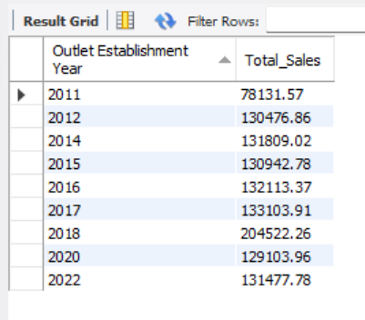

**5. PERCENTAGE OF SALES BY OUTLET SIZE:**

SELECT

`Outlet Size`,

CAST(SUM(Sales) AS DECIMAL(10,2)) AS Total_Sales,

CONCAT(CAST((SUM(Sales) * 100.0 / SUM(SUM(Sales)) OVER()) AS DECIMAL(10,2)), “ %") AS Sales_Percentage

FROM blinkit_data

GROUP BY `Outlet Size`

ORDER BY Total_Sales DESC;

**6. SALES BY OUTLET LOCATIONS**

SELECT `Outlet Location Type`, CAST(SUM(Sales) AS DECIMAL(10,2)) AS Total_Sales

FROM blinkit_data

GROUP BY `Outlet Location Type`

ORDER BY Total_Sales DESC

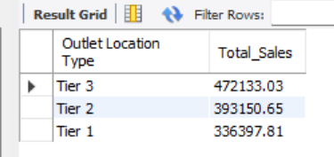

**7. ALL METRICS BY OUTLET TYPE**

SELECT `Outlet Type`,

CAST(SUM(Sales) AS DECIMAL(10,2)) AS Total_Sales,

CONCAT(CAST((SUM(Sales) * 100.0 / SUM(SUM(Sales)) OVER()) AS DECIMAL(10,2)), “ %") AS Sales_Percentage

CAST(AVG(Sales) AS DECIMAL(10,0)) AS Avg_Sales,

COUNT(*) AS No_Of_Items,

CAST(AVG(Rating) AS DECIMAL(10,2)) AS Avg_Rating,

CAST(AVG(`Item Visibility`) AS DECIMAL(10,2)) AS Item_Visibility

FROM blinkit_data

GROUP BY `Outlet Type`

ORDER BY Total_Sales DESC;

